PB Weekly Newsletter 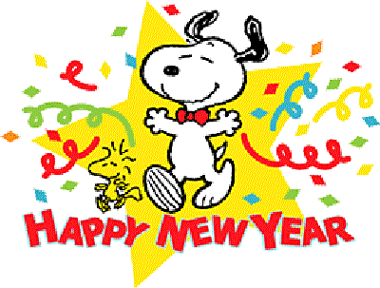

This Week in PB!
Book Corner: Children can share books about The Three Kings.
Writing: Children can make pictures about what they did during Christmas break. They can dictate memories and favorite activities. Focus on the letter N.
Math: Children can make patterns with the number 2 and 0. Count down from 10 to 0 to celebrate the New Year.
Science: Children can make baking soda fizzy liquid for pouring and stirring.
Sensory: Children can explore the sensory table filled with party related items.
Dramatic Play: Children can pretend they are celebrating the New Year with friends with party hats and decorations.
Construction: Children can build with foam blocks up as high as they can. Knock them down and start again.
Art: Children can create art projects about New Year Celebration and The Three Kings.
Religion: Children can understand the story about The Three Kings.
Notes and Reminders
Please keep the “home toys” at home.
We play outside rain or shine! Make sure that your child brings a coat every day!
Please be sure to bring a set of extra clothes and return the ones that we provide.

