PB Weekly Newsletter 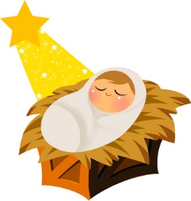

This Week in PB!
Book Corner: Children can share books about kindness.
Writing: Children can dictate words or phrases about how we can show kindness to others. Focus on the letter K.
Math: Children decorate shapes to develop different group projects in class.
Science / Sensory: Children can use magnetic wands to discover what items are magnetics and others that are not.
Dramatic Play: Children can pretend they are at the Cocoa Stand drinking a delicious hot chocolate with friends.
Construction: Children can build houses with Christmas decorations.
Art: Children can create art projects about Jesus, King of Kings.
Religion: Children can understand the real meaning of Christmas is Jesus.
Notes and Reminders
Please keep the “home toys” at home.
We play outside rain or shine! Make sure that your child brings a coat every day!
Please be sure to bring a set of extra clothes and return the ones that we provide.

